**SEPHSUA GLOBAL SALES PERFORMANCE REPORT (2010–2011)**

**1. Introduction**

This report presents a data-driven performance review of SEPHSUA's global sales between 2010 and 2011. Drawing insights from a comprehensive dashboard and supporting dataset, our goal is to uncover patterns, trends, and growth opportunities.

Through this analysis, we aim to understand customer behavior, product demand, and regional market dynamics, ultimately offering clear, practical recommendations to drive SEPHSUA’s expansion and business development in the years ahead.

**2. Story of the Data**

The dataset used in this project represents **global transactional sales** for SEPHSUA over a two-year period (2010–2011). It includes information such as:

1. Invoice details
2. Country and customer location
3. Product descriptions
4. Order sizes
5. Unit price and quantity sold
6. Monthly sales performance

These data points were visualized through a business intelligence dashboard, making it easier to track trends in unit pricing, country-level performance, and product demand.

**3. Pre-Analysis**

Before diving into the analysis, we identified the following:

1. **Industry Type**: Retail & Consumer Goods (Home Décor and Lifestyle Products)
2. **Dependent Variables**:
   1. Total Sales
   2. Total Quantity Sold
   3. Revenue per Product
   4. Country-wise Sales
3. **Independent Variables**:
   1. Product Description
   2. Country
   3. Order Size
   4. Time (Year and Month)
   5. Unit Price

**Key Stakeholders:**

1. SEPHSUA Leadership & Strategy Teams
2. Sales & Marketing Managers
3. Inventory and Supply Chain Teams
4. International Business Development Teams

**What Success Means:**

1. Increased total sales and customer reach
2. Market expansion into new regions
3. Balanced mix of small and large orders
4. Strong sales of both diverse and high-value products

**4. In-Analysis**

Here’s what the data told us during the core of our analysis:

1. Total Sales stood at $9.73M across 5 million units sold.
2. The average unit price was $5, indicating strong appeal in low-cost items.
3. Small orders dominated, making up 80% of sales, while large orders contributed 20%.
4. 26,000 orders were placed by 4,373 customers, showing healthy transactional activity.
5. The most ordered product size was consistently labeled as “small order”.
6. United Kingdom led sales by a wide margin with $8.2M, while other European countries lagged significantly behind.
7. High-value products like the “Picnic Basket Wicker 60 Pieces” ($649.95) showed strong revenue despite low volume.

**Sales Trends:**

1. Sales peaked around mid-2010 and Q2 2011, with a few drops suggesting seasonal or campaign-driven spikes.
2. Popular items were largely inexpensive home or gift items, with large volumes contributing to high revenue.

**5. Post-Analysis and Insights**

After completing our deep dive, several key insights emerged:

1. Product Popularity Varies by Region: The UK clearly drives most revenue, but the untapped potential in European and Asian markets is evident.
2. High-volume, low-cost items dominate, but high-ticket items generate strong per-unit revenue and need more visibility.
3. SEPHSUA is heavily consumer-driven, with very little B2B or wholesale activity visible.
4. There’s a mismatch between product diversity and promotion strategy. high-value items aren't being featured enough.

**6. Recommendations and Observations**

Here’s how SEPHSUA can use the data to drive smart growth:

1. Expand Globally, But Intelligently

Focus on Europe and Asia, where there’s room to grow. Start with countries already showing engagement and use data to tailor messaging and product offerings.

2. Use Regional Product Models

Track which products perform best in which countries, and adjust online catalogs accordingly. Not all products will work everywhere—localize with purpose.

3. Balance Product Diversity with Promotion

Keep offering a variety of items, but put premium products front and center. Use bundling and curated collections to raise the average order value.

4. Unlock B2B Potential

Small orders are great, but SEPHSUA should start offering incentives for bulk purchases. Build business-focused ordering paths for small retailers, event planners, and designers.

**7.Visualization**

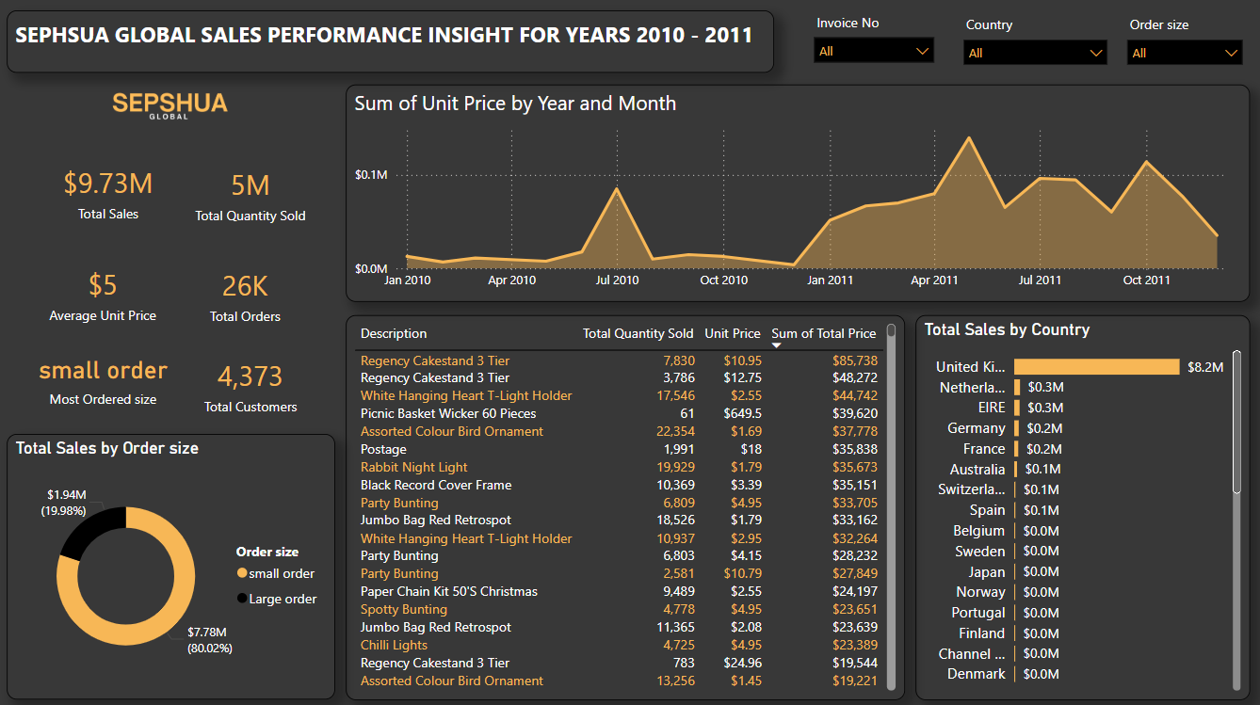

Sephsua Global Sales Performance Insight for Years 2010 - 2011

**8. Conclusion**

SEPHSUA has built a strong foundation in the UK, supported by a broad product range and consistent customer engagement. But if the brand wants to grow further, it needs to:

1. Think global, act local
2. Prioritize high-impact products
3. Balance consumer and business sales
4. Leverage data at every decision point

By following these strategies, SEPHSUA can evolve from a local leader into a global lifestyle brand relevant, responsive, and ready for the next chapter